Software for Solenoid Control

I was concerned about the airflow through the cylinders. If we use just one solenoid for each side of the two cylinders will we have enough air flow. I think before we were using two solenoids per side. Thoughts?

Here is what I was working on before I had the thought above…

* Use three double solenoids for controlling the cylinders
* Gripper
  + Controlled by one double solenoid
  + Use channels 1 and 2 for each side of the cylinder.
  + Use forward and reverse to control the gripper
* Catapult
  + Dual cylinders controlled by separate cylinders for each side
  + Chanel 3 for the ball pickup
    - Channel 7 for the 2nd side of the solenoid – which will not need to be connected
  + Channel 4 for shooting the catapult
    - Channel 8 for the 2nd side of the solenoid – which will also not be connected.
  + Note that the software requires that there be two channels per double solenoid

We are currently going with three double solenoids for our control. For some experiments with single solenoids I was going to use channels 5 and 6.

Here is the table from the control spreadsheet:

|  |  |  |
| --- | --- | --- |
| Gripper – Opening | Breakout 1 Solenoid Channel 1 | Gripper |
| Gripper – Closing | Breakout 1 Solenoid Channel 2 | Gripper |
| Catapult - Ball Pickup | Breakout 1 Solenoid Channel 3,7 | Pick Up Pose |
| Catapult – Shooting | Breakout 1 Solenoid Channel 4,8 | Shoot |

Here is the software from the Begin.VI showing the initialization for the solenoids. The attempt is to match the table above.

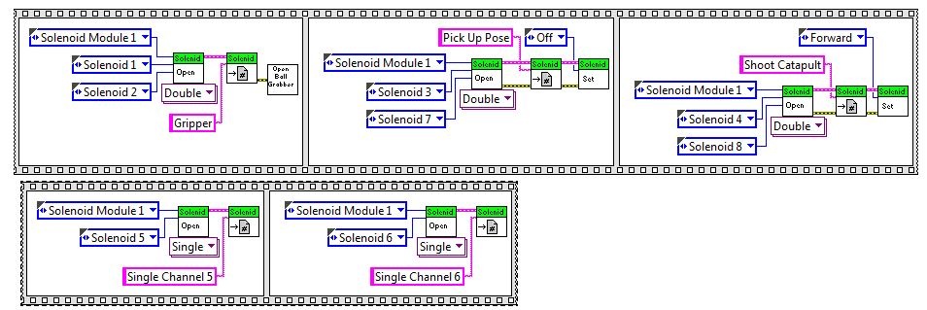

I put these in a sequence to guarantee the execution order. The gripper initialization is executed first and then the pick-up pose initialization executes and turns that solenoid off. The initialization for the ‘shoot catapult’ executes last and is turned ON. This is intended to place the catapult in the up position for the start of the match.

For testing the single solenoid, channel 3 in the code below, I’ve used the button on joystick 3 to control the setting the solenoid to off, on, forward, and reverse. Here is the test code:

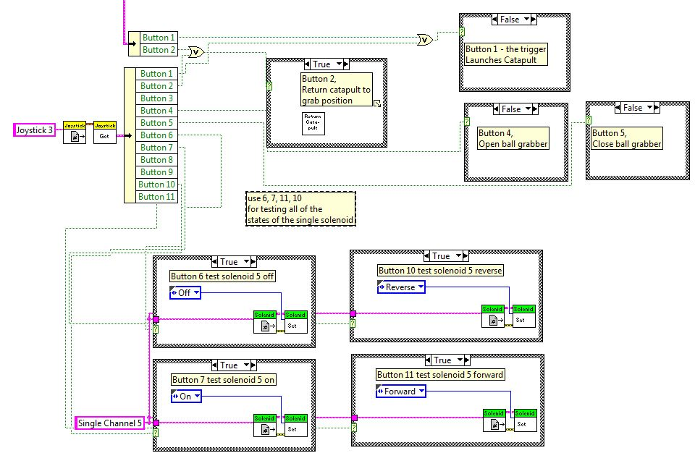

Here is a blow up of the test code:

